Budgetwise
Week 7 | 2026-03-28 - 2026-04-03

Leader: Marcelo Mejia

Jonathan Gruber  Time Spent  20 hours | Tasks completed:  - Revise back end for sending reset-password email.  - Update architecture diagram  Planned tasks for next week:  - Finish linking front end and back end for forgot password and reset password.  - Forward 4xx error messages from back end to front end.  - Maintain architecture diagram.  - Help implement any remaining back-end functionality.  Any issues or challenges:  - None.
Casandra Marquez  Time Spent  21 hours | Tasks completed:  - Resolved merge conflicts from last week  - Migrated database from SQLite to PostgreSQL using Prisma and resolved migration issues  - Converted frontend from Vite to Next.js to resolve Docker build failures  - Created Dockerfiles and configured Docker Compose for PostgreSQL, backend, and frontend  - Resolved container startup, networking, and port conflicts  - Verified full Docker environment working across all services  - Updated README  - Created Docker setup guide https://docs.google.com/document/d/1fCCBXvEHDShtw9DJg74m3M7Wn9nTcDTBp5rjNiWTr7c/edit?usp=sharing  Planned tasks for next week:  - Continue refining Docker setup for deployment readiness  - Deploy  Any issues or challenges:  - Prisma migration errors and configuration issues  - Docker build failures due to Vite configuration  - Port conflicts during container setup
Haru  Kimura  16 hours | Tasks completed:  - Integrated frontend forgot-password and reset-password pages with backend API endpoints  - Implemented API calls using NEXT_PUBLIC_API_BASE_URL environment configuration  - Set up and configured local environment variables for frontend and backend  - Resolved CORS issues to allow frontend-backend communication  - Fixed runtime error caused by rendering backend validation objects in React  - Implemented error parsing to properly display backend validation messages in UI  - Successfully tested forgot-password and reset-password request flows end-to-end  Planned tasks for next week:  - Assist with merging branches and final integration testing  - Help refine UI/UX or error handling if needed  - Support any remaining backend/frontend synchronization issues  Any issues or challenges:  - Encountered issues with environment variables not loading correctly, which caused API requests to fail initially  - Faced CORS blocking between frontend (localhost:3000) and backend (localhost:5001)  - Backend returned structured validation errors (objects), which caused React rendering crashes  - Required debugging across frontend, backend, and local environment setup
Marcelo Mejia  Time Spent  15 hours | Tasks completed:  - Merged team members work in the Github  - Updated Jira tasks  - Added many UI changes, feature additions, and bug fixes. As stated last week, I wanted to make the app more visually appealing. While I did do that in some ways, I mostly focused on making our app feature more intuitive and user friendly:  - Expenses Page:  - Users can now choose multiple expenses in the expenses page to delete. They are prompted with an “are you sure” popup before deletion.  - Income/Expenses/Net summary at the top of the page can now be changed to different months, either using the arrows or by choosing a month from the dropdown button  - Only expenses for the chosen month will be shown  - A search function was added that can find specific transactions based on its expense category or note attached to it. Alternatively, the user can now sort expenses by a specific category for the current month, year, or all time  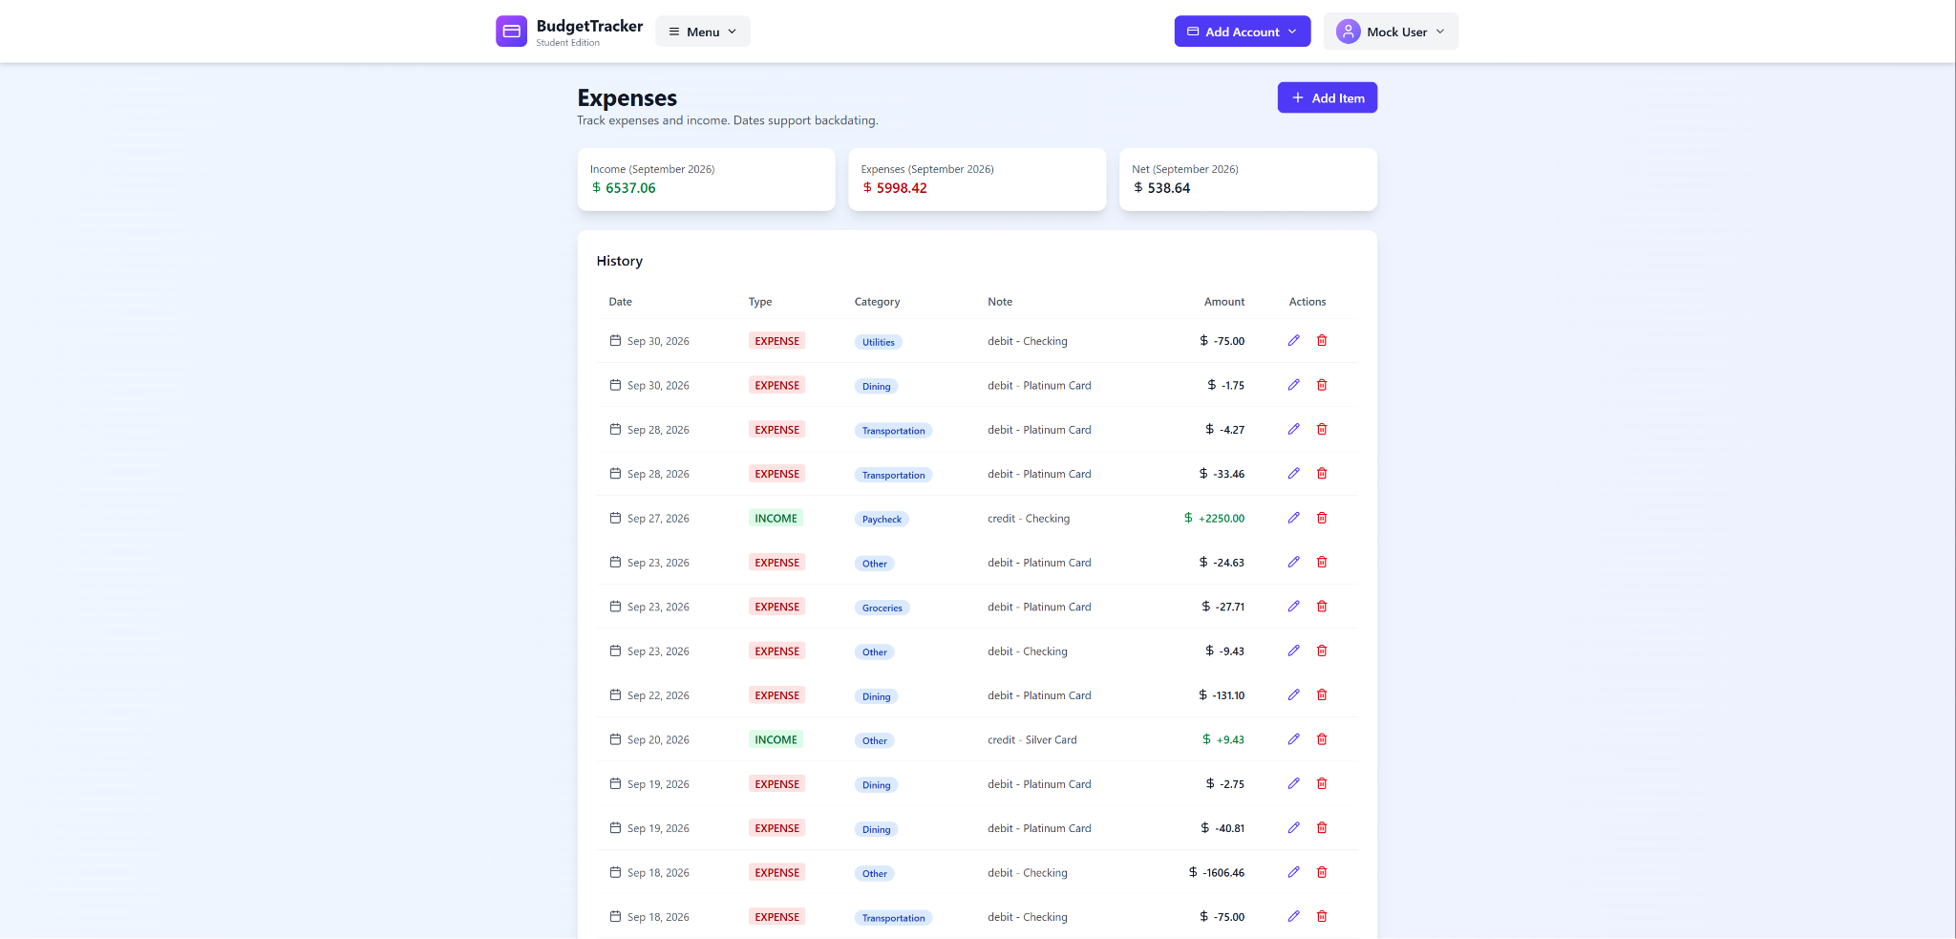  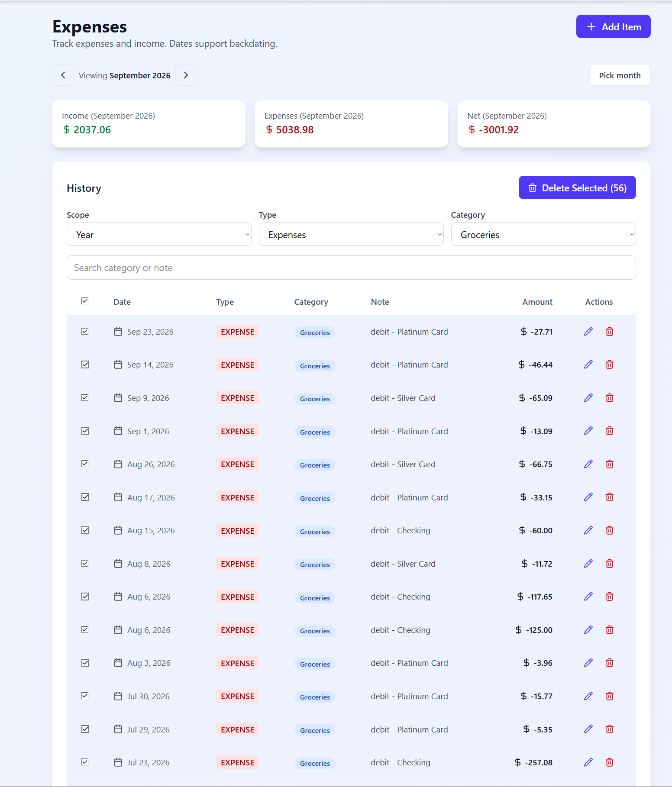  - Calendar Page  - The calendar size was increased to make it easier to see and read  - Made the summary table to the right easier to read by changing the background color  - Added a legend at the top for users to associate the color codes in the calendar with one of the expense categories  - The monthly net income/expense values were being loaded each time the user clicked a date. I found this to be a bit redundant, so I added a static box for these values below the calendar  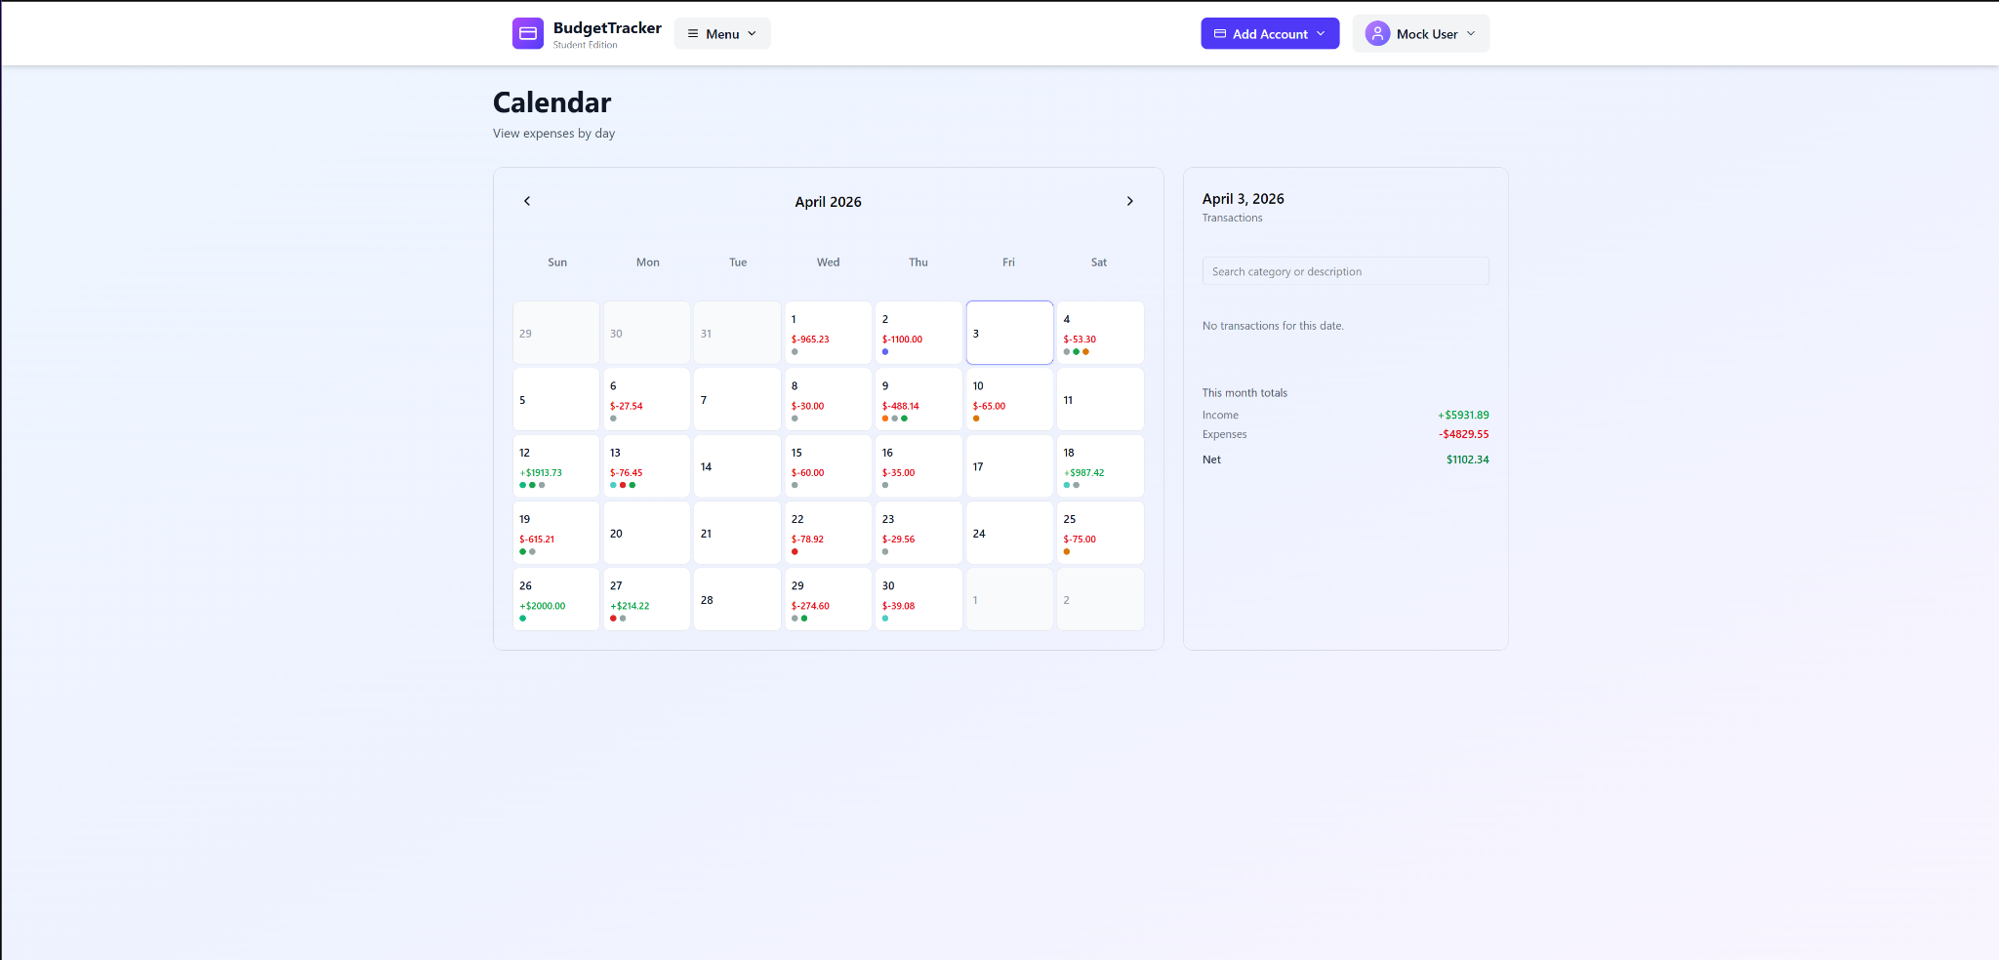  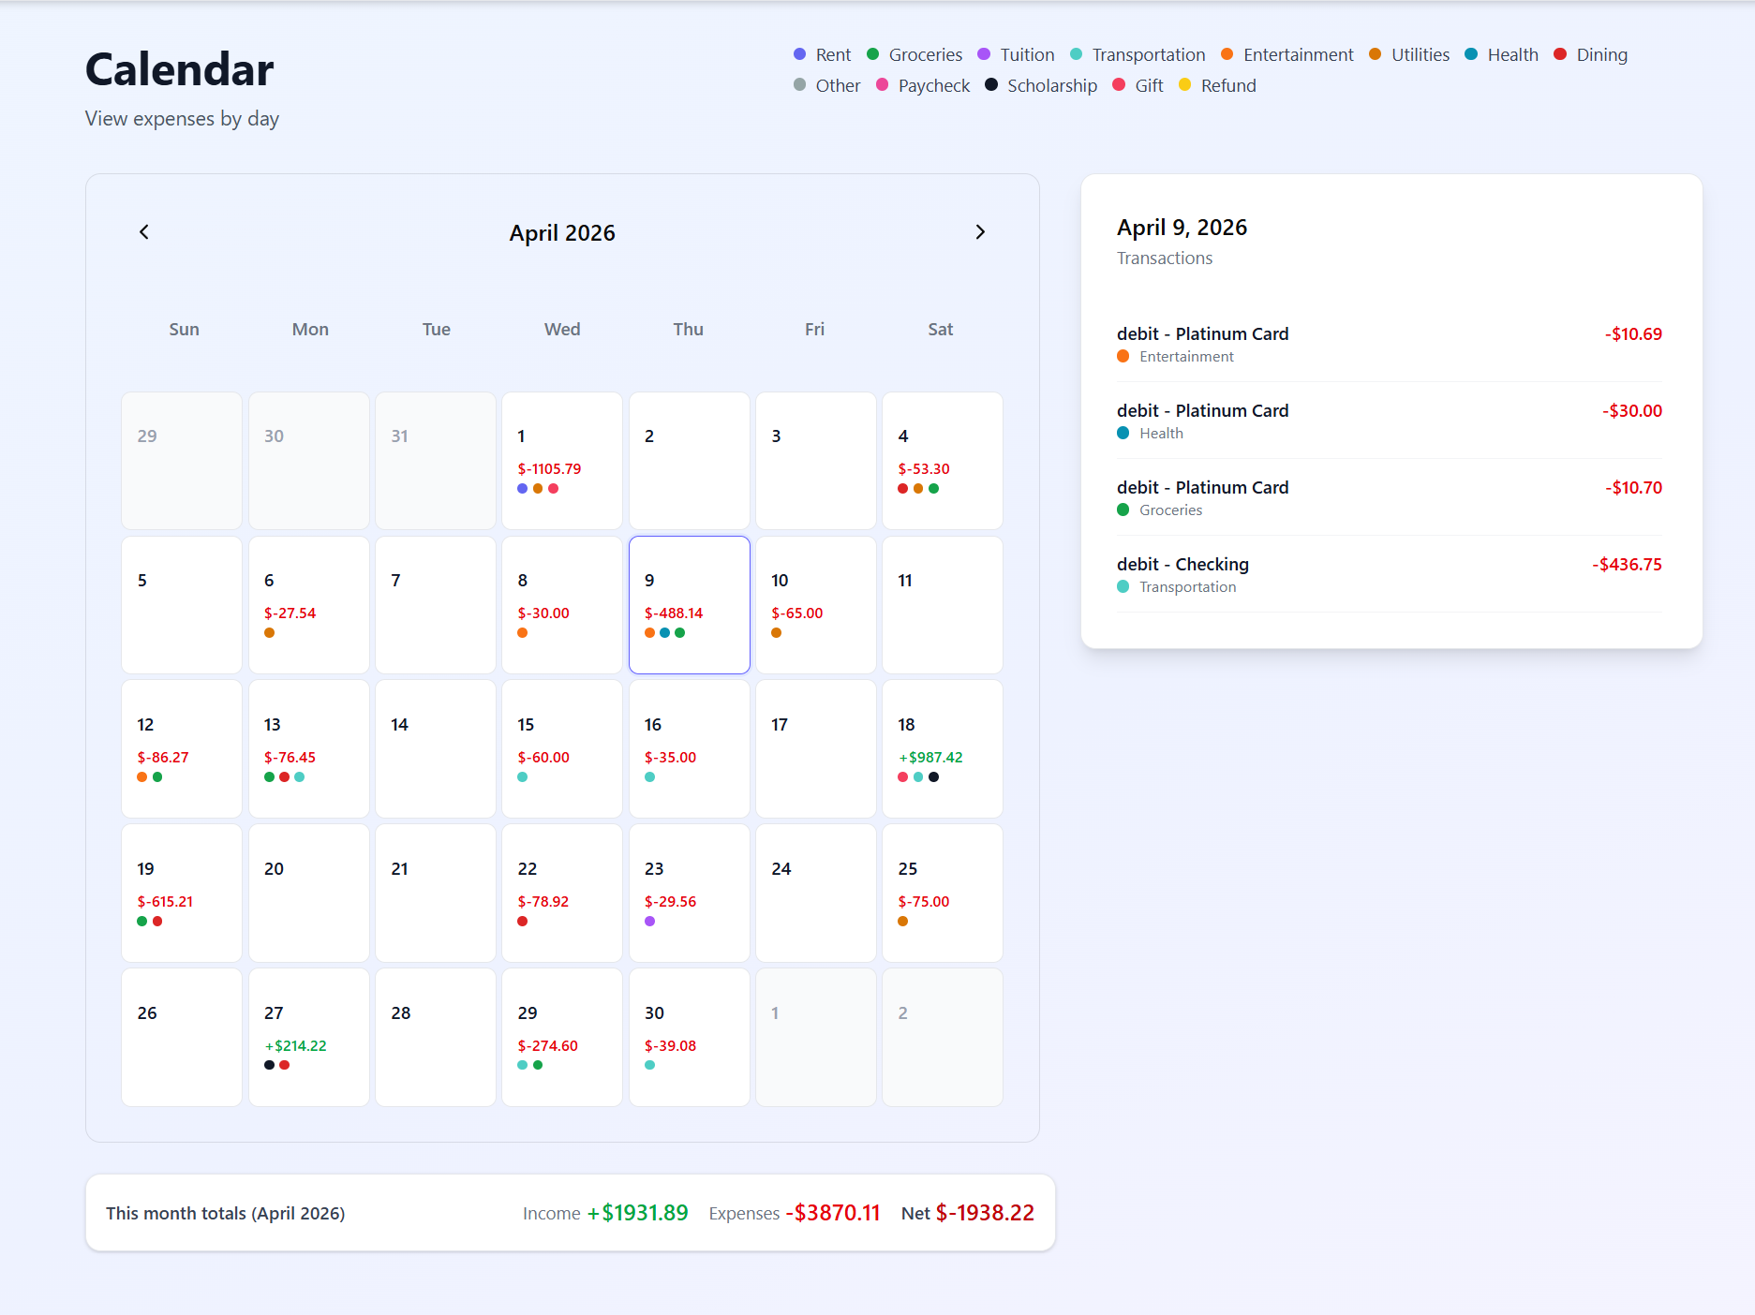  - Dashboard page  - The bar chart was displaying a negative budget remainder value, so that was fixed to mirror what was in the budget creator page  - The AI optimized budget creator box displayed an older version where 12 expense categories were being used, changed to 9 categories.  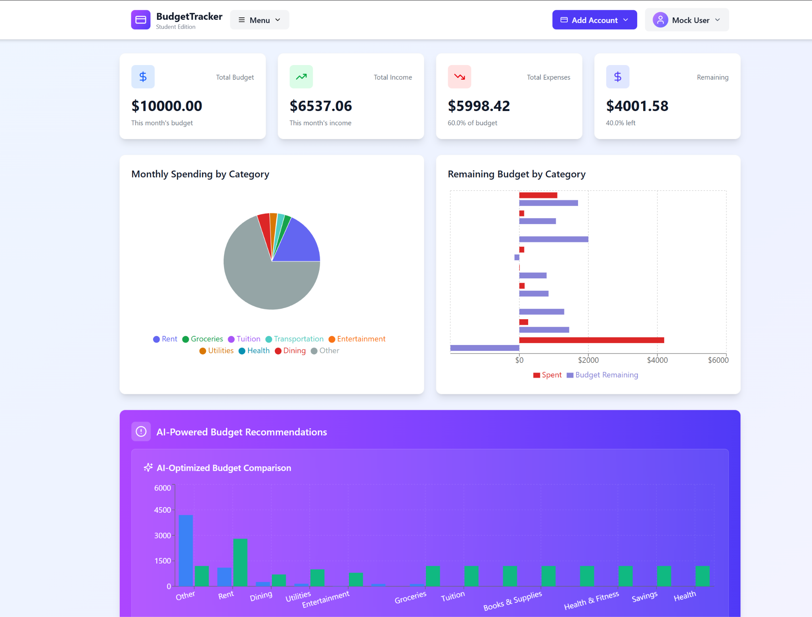  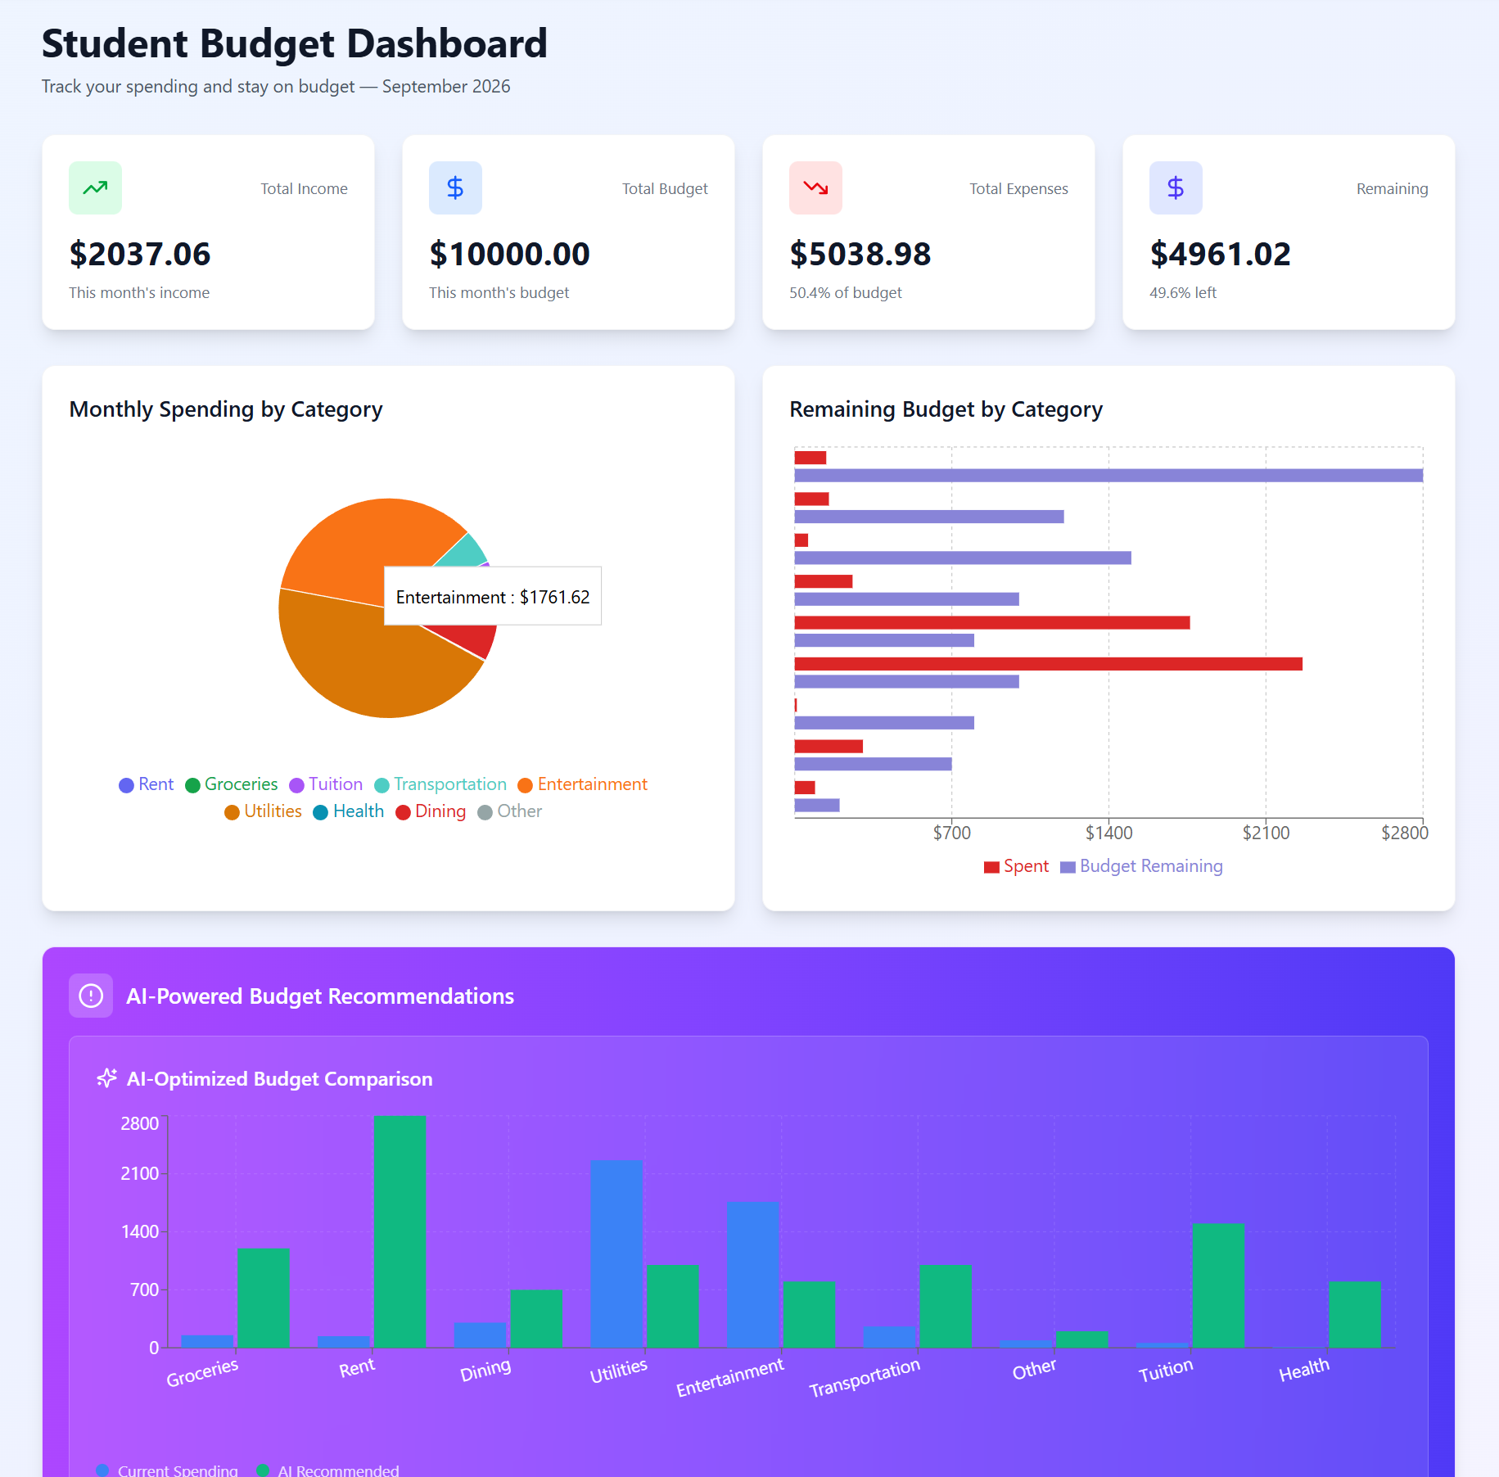  - Settings Page  - As part of a task in the project specs that was left unfinished, a “delete account” feature was added to the settings page. Deletes the username, password, and all data associated with it in the database.  Planned tasks for next week:  - Since I feel like most things are in place at this point, I want to provide help where I can with the AI features and testing, or wherever else I’m needed.  Any issues or challenges:  - Wanted to add a recurring charge feature, couldn’t really get it working in time
Jonathan Strong  Time Spent  12 hours | Tasks completed:  - Fixed budget creator page  - You can now increase or decrease the amount of each category except for the other category which is calculated based on any potential remaining budget.  - You can now increase or decrease percentage of each category up to 100%  - It won't let you save the budget until all percentages add up to 100  - Fixed slight issue with bar chart in the dashboard  - Now displays budget remaining correctly  - Updated test cases to reflect new changes to budget creator page  - All updated or new test cases are bolded  - https://docs.google.com/spreadsheets/d/1vOoeru3KVPgzfKPksLUyNN6EUk7s1ceKKEgNK8J5trw/edit?usp=sharing  Planned tasks for next week:  - Assist with any tasks needed  - Scalability test cases  Any issues or challenges:  - Some slight merge conflicts when pulled from front_back_merge
Sophia Chau  Time Spent  13 hours | Tasks completed:  - Fixed the problem with small suggestions  - Implemented AI on the AI budget creator  - Created a planning document for scaling up the program  Planned tasks for next week:  - Finalize AI implementations and test all the features  - Add more detail to the planning document  Any issues or challenges:  - Time constraints with personal issues  - Exams next week

Total Time Spent: 97 hours

Summary:

